CLE Tracker/ASP Web Pages Installation and Administration
Copyright ©2001, ©2002 Urick Consulting LLC. All rights reserved.

This software and documentation are copyrighted materials.

Notice
This documentation is provided "as is" without warranty of any kind, expressed or implied, including but not limited to, the implied warranties of fitness for a particular purpose.

While reasonable efforts have been made to assure the accuracy of this document, in no event will Urick Consulting LLC be liable for direct, indirect, incidental, or consequential damages resulting from any defect in this publication, the CLE Tracker software or ASP Web Pages. Urick Consulting LLC reserves the right to change this document at any time without obligation of notification.

Trademarks

Microsoft, Access 97, Access 2000, Windows 95, Windows 98 and Windows NT are trademarks or registered trademarks of Microsoft Corporation.

CLE Tracker and CLE Tracker/ASP are trademarks of Urick Consulting LLC

Urick Consulting LLC
29727 Vita Lane
North Olmsted, Ohio 44070

Web: www.cletracker.com
E-mail: sales@cletracker.com

Revised 2/1/2002
CLE Tracker/ASP
CLE Tracker/ASP allows connecting CLE Tracker and CPE Reporter databases to your corporate Intranet web site. This allows users to view and or update their continuing education credit information using just a web browser. Users enter username and password information into a login screen to gain access to their information. There are also special logins for administering the system as well as special management logins to allow viewing employee credit summaries for entire offices or practice groups.

CLE Tracker/ASP Web Pages Installation and Administration
This document will explain the process of installing and configuring the CLE Tracker/ASP web pages into an existing corporate Intranet web site. There are several tasks that need to be performed to complete this process. These tasks may be performed by one or more people depending upon your organization and the different areas of responsibility within your company.

An understanding of the how CLE Tracker and CPE Reporter works and how the ASP web pages are used to connect to the continuing education credits databases will help to explain the need and to assist in the process of completing the different tasks. (see Figure 1.)

How CLE Tracker and CPE Reporter work.
CLE Tracker and CPE Reporter are Microsoft Access database programs that consist of two parts. A front-end program part and one or more back-end databases for storing employee and continuing education credit information. The front-end CLE Tracker program is able to connect to the different back-end databases through a local area network allowing the databases to be stored on a central file server and the CLE Tracker front-end program to reside on the user’s desktop PC. This arrangement allows one professional development coordinator using CLE Tracker to administer one or more CLE back-end databases as needed.

How the ASP Web Pages work.
Just like the front-end program parts of CLE Tracker and CPE Reporter, the ASP web pages are able to connect to the back-end databases containing employee and continuing education credit information. Using this connection, the ASP web pages are able to display and update employee and continuing education credit information.

The ASP Web pages contain Visual Basic programming code that is interpreted by the web server when a user requests a web page using their Web browser. The result of this Visual Basic code is an HTML document that is displayed to the user’s web browser.

Web users must enter a valid login username and password to access their CLE information. These usernames and passwords are maintained in a separate Access 97 or Access 2000 database.(CELogin.mdb) When a valid login username and password are entered, the ASP web pages obtain the user’s employee ID, their security access code and the ODBC data source name to connect to the proper back-end CLE database.

With this quick overview of CLE Tracker and the ASP web pages, we can now describe the different tasks that need to be completed.

Microsoft IIS Web Server with CLE Tracker-ASP Web pages and CLE databases.

LAN
Microsoft IIS Web Server
ASP Web Pages
CELogin.mdb
CLE Tracker Databases
ODBC
desktop PC
CLE Tracker Program

Figure 1.

The required tasks can be grouped by the role of the person needed to perform each task. These roles are as follows:

CLE Coordinator, IntraNet Webmaster, and CLE-ASP logins coordinator.

TASKS:

CLE Coordinators

The first step is for the CLE coordinators to determine the number of CLE databases they need to maintain. This is a function of the number of branch offices and their locations where they will provide tracking of CLE credit information. A separate CLE-ASP remote site license is needed for each branch office remote site that will be accessing the CLE-ASP web pages. Using the CLE Tracker program, the coordinator can create and configure the required number of CLE Tracker back-end databases. Configure each CLE Tracker database and add the user information for each attorney.

The CLE Tracker back-end databases can be named any appropriate name as long as they maintain the .mdb extension. For example, you could have CLE Tracker back-end databases named OH2001.mdb, NY.mdb and CA2001.mdb. Use Windows explorer to rename these files as needed.

For assistance using CLE Tracker, refer to the “CLE Tracker Users Guide” and the “CLE Tracker Installation, Configuration and Customization Guide” provided with CLE Tracker.

IntraNet Webmaster
The IntraNet webmaster needs to install the ASP web pages, create the required HTML links, copy the CLE login and CLE Tracker databases to the web server, and create the ODBC data sources.

IntraNet Webmaster – Installing the ASP web pages.
The ASP Web pages are provided on the CD-ROM in the /CE directory that also contains a /images subdirectory that must be maintained. All of the web pages begin with the letters CE.

The webmaster should create a directory on the Internet Information Server system and copy the ASP web pages and images subdirectory to this new folder. This new folder can then be made a new virtual directory or added to an existing virtual directory as needed. This decision is beyond the scope of this document.

IntraNet Webmaster – Installing the CElogin database.
The CElogin.mdb database stores usernames and passwords. The CELogin.mdb file in located on the CD-ROM in the /LOGIN directory. Copy this CElogin.mdb file to a suitable location on the web server. This database does not need to be stored in a shared location as it can be maintained through a web browser, however, for back-up purposes you may want to share this directory.
Remember to change the file permissions on this file because it is read-only when copied from the CD-ROM.

IntraNet Webmaster – Installing the CLE Tracker back-end databases.
For best system performance, the CLE Tracker back-end databases should be stored on the web server. Create a directory and copy the CLE Tracker back-end databases created by the CLE coordinator. This directory should be a shared directory to allow the CLE coordinator to connect to these databases using the CLE Tracker program on this local area network and also to provide for daily back-up of these files.

IntraNet Webmaster – Create the ODBC data source for CElogin.mdb
Using the ODBC Data Source Administrator, create a System DSN called “dsnCEuserlogin” and connect it to the CElogin.mdb file stored above.

IntraNet Webmaster – Create the ODBC data sources for the CLE Tracker back-end databases.
The CElogin.mdb database contains a table of dsn names, dsnCEDB1, dsnCEDB2 … to dsnCEDB15. More can be added as needed. Using the ODBC Data Source Administrator, create the System DSNs dsnCEDB1, dsnCEDB2, etc, etc and connect them to the CLE Tracker back-end databases stored above. Note the name of the database connected to each dsn ODBC connection.

For example, using the ODBC Data Source Administrator we would create a system DSN called dsnCEDB1 and connect it to OH2001.mdb.

IntraNet Webmaster – Create the HTML links.
All user entry to the CLE-ASP web pages start with the CELogin.asp page. You need to create the HTML links from your existing IntraNet site to this web page and also determine where in your IntraNet site users should be returned to when they have completed using the CLE-ASP web pages.

For example, if you stored the CLE-ASP web pages in a directory called CE, then the entry point would be http://hostname/CE/CElogin.asp.

Create the required HTML links in your IntraNet site to point to the CElogin.asp page.

Modify the “home” link in CElogin.asp to return users to your IntraNet site. (line #110)

The CE logo also has a return link that should be set. Modify the link in the CEHeader2.asp (line #71) and CEHeader3.asp (line #25) files to return users to your IntraNet site when they click on the CELogo at the top of each web page.

The CELogo.jpg file displayed at the top of each CLE-ASP web page can also be edited to match your company Logo. This file resides in the /CE/images directory. Just replace this file as needed. It is 600x80. If the new file is a different size, update the width and height dimensions in the CEHeader2.asp and CEHeader3.asp files.

CLE- ASP logins coordinator.
At this point the CLE-ASP web pages are installed and the last step is to create the login usernames and passwords for each user. Before beginning this step you need to know the employee ID assigned to each employee, what DSN (database) they connect to, his or her login username and password and the desired access permission.

The CELogin.mdb file comes with one user login called “ADMINISTRATOR” with a password of “SYS”. You can change this password as needed and you can also create additional administrator user logins.

- Using a web browser, connect to the CElogin.asp page. (shown below)

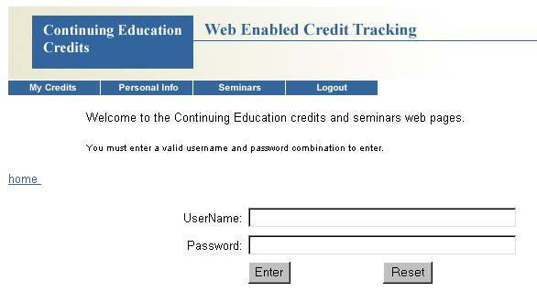

- Enter the username “administrator” and password “sys”. (Usernames and passwords are not case sensitive.) This will display the System Administrators page as shown below.

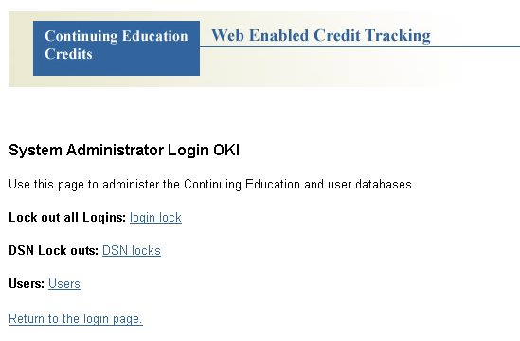
- Select DSN locks to display the DSNs page as shown below.

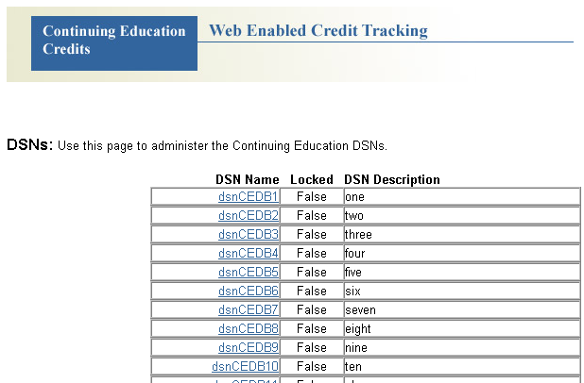
- Click on the dsnCEDB1 link to display the DSN page. The database is shipped with 15 dsns already entered. You may add more as needed.

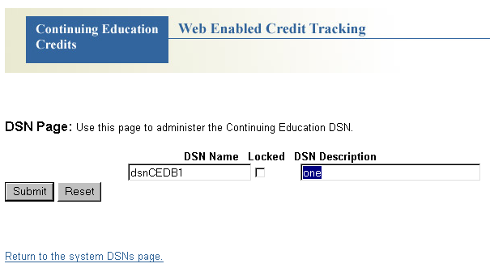
- Enter a description for this DSN and press the submit button to save your changes. Repeat for all DSNs that you are using. Adding this descriptive text will assist you when assigning DSNs to user logins.

The “Locked” checkbox is used to lock this DSN and prevent users from logging in that use this DSN (database). It does not kick off users already logged in. The login lock on the System Administrator page prevents all users from logging in, except for administrator accounts. Users attempting to login while the system is locked, will receive a DSN locked or System locked message. A single user can also be locked out and prevented from logging in by assigning them an access code other than 11,22,33, or 44.

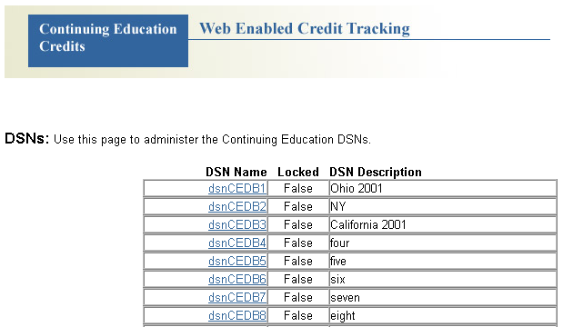
- Return to the System Administrator Login (syslogin) page.
- Select Users to display the user logins page as shown below.

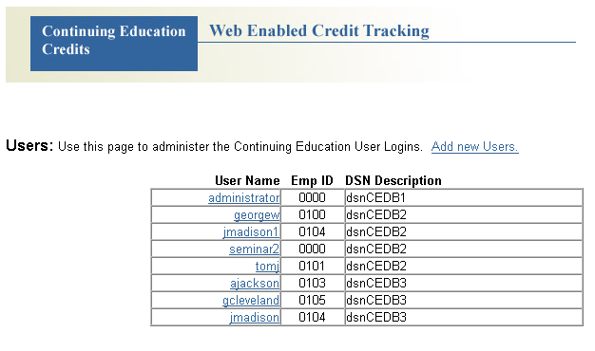
- Select “Add new Users” to add a new user login.
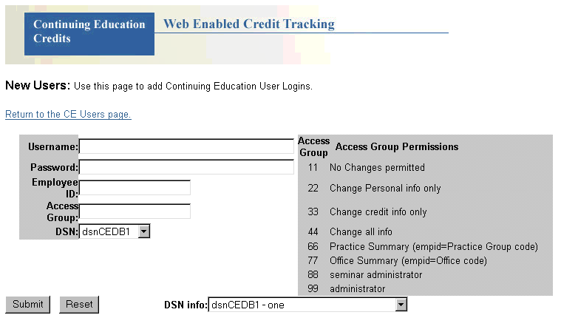

- Enter a login username, password, employee ID and access group permission and select the proper DSN for this new user. The “DSN info” pull-down will display the DSN descriptions if needed. Then press the submit button to enter this new user login.

Users may belong to more than one CLE Tracker back-end database. This can occur when an attorney maintains licenses in more than one State and the States have different CLE requirements and/or different reporting dates. A separate username and password is required to access each database. The login username must be unique, so two users cannot have the same login username.

The Access Group Permission determines the type of information that users are allowed to modify. They are also used to signify administrator, seminar administrator and supervisor type accounts. Only one administrator account is needed. A seminar administrator account is needed for each CLE Tracker back-end database where you wish to maintain CLE seminar information using the ASP Web pages. Seminar administrator accounts can have any employee ID number because it is not used. Supervisor login accounts have an access code of 77 and their employee ID number should be set to the id code of the office they supervise. The supervisor login will provide them a summary of credits for all employees in this office location.

Administering CLE Tracker - ASP web page databases.
The Microsoft IIS server configuration in figure 1 shows a CLE coordinator PC running CLE Tracker connected to the CLE Tracker back-end databases directly over the local area network. In this configuration, the CLE coordinator would use the CLE Tracker program to connect to the back-end databases to create new attorney accounts, update CLE seminar information and create company wide reports.

If this configuration is not possible because the CLE coordinators are not connected to the same local area network as the Microsoft IIS web server, it is still possible to maintain the CLE Tracker back-end databases through the ASP web pages. Seminar information can be maintained by using the seminar administrator accounts to add/modify and delete seminar information. New attorney accounts cannot be added through the ASP web pages, so a little planning ahead is needed. When setting up the CLE Tracker back-end databases, the CLE coordinator can create future attorney accounts and assign them employee ID numbers. Then when a new attorney is hired, he/she can be assigned one of these future accounts and be given a login username and password to access this new account. In this configuration, the CLE Tracker back-end databases will need to be copied and sent to the CLE coordinator to create company wide reports using the CLE Tracker program. This process could be performed each month or as needed.

Deleting CLE credits
Attorneys are now able to delete all their CLE credit information with one command provided they have the correct access permission to modify their CLE credit information. Go to “My Credits” page and select the “show fees and expenses”. At the bottom of this page is an entry box for entering a delete code and a submit button labeled “Delete my CE credits”. (see below)
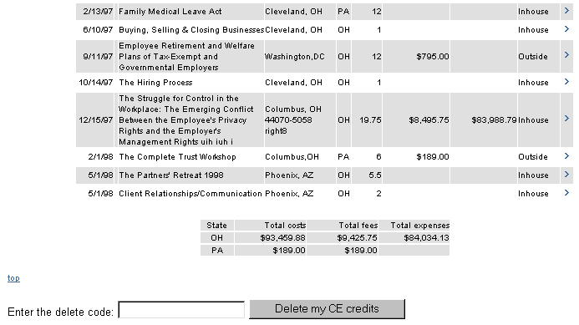
To delete all your CLE credits, enter the delete code and press the button. The delete code is: Delete my CE credits. Exactly as shown on the button label.

