Continuing Legal Education Credit Tracking and Reporting System

Installation Configuration and Customization Guide
Version 4.0

Copyright 1998 - 2005 Urick Consulting LLC. All rights reserved.

This software and documentation are copyrighted materials.

Notice
This documentation is provided "as is" without warranty of any kind, expressed or implied, including but not limited to, the implied warranties of fitness for a particular purpose.

While reasonable efforts have been made to assure the accuracy of this document, in no event will Urick Consulting LLC be liable for direct, indirect, incidental, or consequential damages resulting from any defect in this publication or the CLE Tracker software. Urick Consulting LLC reserves the right to change this document at any time without obligation of notification.

Trademarks

Microsoft, Access 2000, Access 2002, Access XP, Access 2003, Windows 98, Windows ME, Windows NT, Windows 2000 and Windows XP are trademarks or registered trademarks of Microsoft Corporation.

CLE Tracker is a trademark of Urick Consulting LLC

Urick Consulting LLC
29727 Vita Lane
North Olmsted, Ohio 44070

Web: http://www.cletracker.com/
E-mail: mailto:info@cletracker.com

This document was modified January, 2006 for CLE Tracker version 4.0.
Purpose
The purpose of this guide is to assist you with installing and configuring CLE Tracker. The guide consists of two sections. The first section discusses installing and configuring CLE Tracker. The second section discusses the structure of the program, (front-end and back-end), running it over a Local Area Network (LAN) and using multiple databases.

Who should read this?
CLE and Professional Development Coordinators should read this entire guide to be familiar with the different program settings and their functions. The second section of this guide is intended for network administrators to help in setting up the back-end database(s) on a file server.

Introduction
CLE Tracker is an easy-to-use program to assist CLE and Professional Development Coordinators with the labor-intensive task of tracking CLE credits and seminar information for hundreds of employees. Created as a Microsoft Access application program, CLE Tracker is a multi-user and multi-database application. CLE Tracker consists of a front-end program and at least one back-end database.

You can use CLE Tracker to create separate back-end databases for each state or reporting entity that you track and report CLE credits. Each CLE Tracker database is configured independently to match each reporting entity credit and time frame requirements. CLE Tracker can connect to these different back-end databases locally or over a local area network. When CLE Tracker connects to a database it reads the configuration settings and adjusts the menu and report options presented to the user.

Hardware and Software System Requirements for CLE Tracker

System Requirements
CPU | Pentium 133 MHz or faster
RAM | 128 MB
HARD DISK SPACE | 10 MB free
VIDEO | SVGA 800x600 resolution
OPERATION SYSTEM | Windows® 98/ME, Windows® NT4.0/2000/XP
APPLICATION SOFTWARE | Microsoft® Access 2000, 2002/XP or Access 2003

Installing CLE Tracker
CLE Tracker is installed using a single installation setup file. (i.e. CLE_2Rprtr31.exe). This file is available via CD-ROM or by downloading from our web site, www.cletracker.com . After downloading this file, use Windows Explorer to locate the file and double-click it to start the installation process. (Windows NT and XP users may require logging in using an account with administrator privileges.) Follow the installation screen prompts to complete the installation.

It is recommended that you install CLE Tracker in the default C:\CLE directory on your local computer. In the second section of this guide, you will learn about moving the back-end database(s) portion of CLE Tracker to a file server. The installation process will create both a desktop icon and a Start menu entry for starting CLE Tracker.
Removing CLE Tracker
If you wish to remove CLE Tracker from your system, it is easily removed. Use the system control panel to remove CLE Tracker from your system. Click on the Windows Start menu and select Settings and select Control Panel. Then select Add/Remove Programs. Select CLE Tracker from the list of installed programs and select the Add/Remove button to start the uninstall process. Follow the prompts to complete the uninstall process. (Windows NT and XP users may require logging in using an account with administrator privileges.) Select the automatic uninstall.

Starting CLE Tracker
CLE Tracker can be started from the desktop icon or from the Start menu.
Click on the Windows Start menu and select Programs and then select CLE Tracker to open the CLE Tracker choices and then select CLE Tracker. When CLE Tracker starts it will display the Main Menu as shown in figure 1.

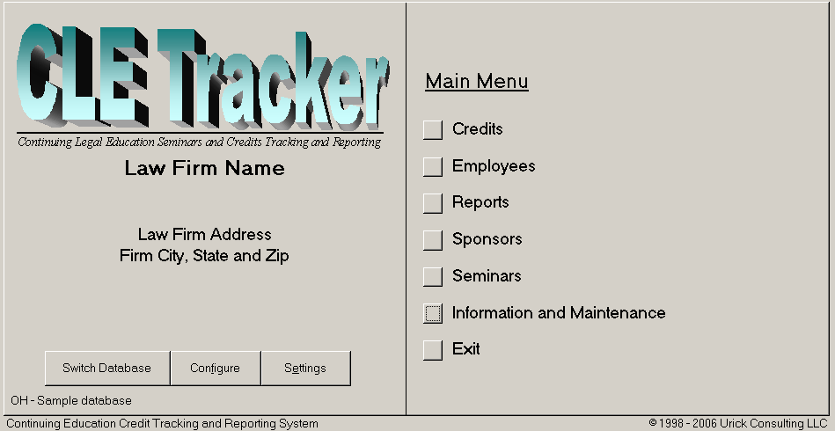
Fig 1

Configuring and Customizing CLE Tracker
Before using CLE Tracker for the first time, you need to configure it to match your state CLE requirements and to customize it with information about your firm using the Configuration and Customization form shown on the next page. (see Fig 2) You open this form using the “Configure” button on the main menu.

The information entered in the Configuration menu configures the program options and determines the menu and report options presented to the users.
The Configuration and Customization form
The Configuration and Customization form is the heart of the CLE Tracker program. You will use this form to configure and customize CLE Tracker to your needs. You may return to this form as often as needed to make changes to the custom settings. From this screen you will configure the back-end database for all users. The information entered here is stored in the back-end database and will affect all users that connect to this database.

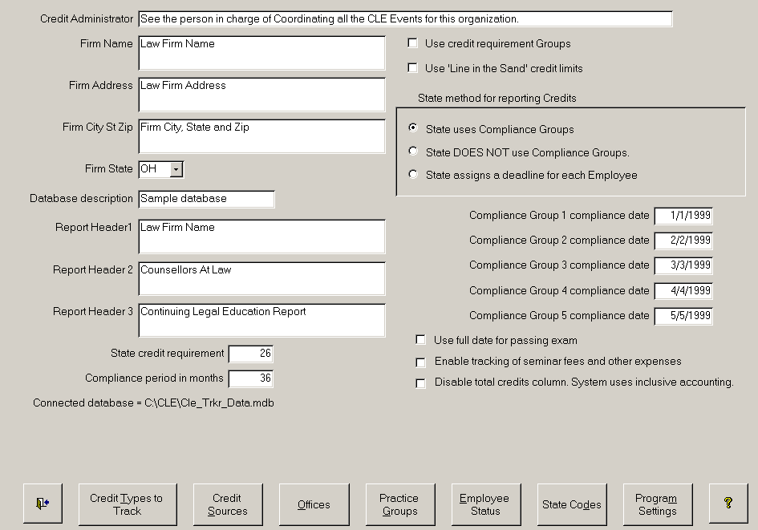
Fig. 2
10
11
12
13
2
1
3
4
5
6
7
8
9

The concept of tracking and reporting credit information is very simple. First we need to establish the compliance date when all the credits must be earned and second we need to set the required number of credits. The configuration and customization form allows you to enter this information.

Configuration and Customization – the heart of CLE Tracker.
As we mentioned before, the Configuration and Customization form is the heart of the CLE Tracker program. The most important configuration setting is State Method for reporting Credits. Item 10 in Fig 2.

(10) State Method for reporting Credits. This all comes down to how your state organization assigns the compliance date for completing credits. There are only three choices;
1 Your state uses compliance groups, or
2 Your state DOES NOT use compliance groups and everyone is assigned the same date or
3 Each member is assigned their own unique reporting date.
As you select these different options you will see the different form fields appear and disappear as needed.

If your state organization divides their members into different reporting groups with different reporting dates, then select the first option. When this option is selected you will see five fields to enter a compliance date for each compliance group. If your state divides members into only two or three groups, leave the remaining date fields blank. If your state requires everyone to earn and report credits for the same time period (option 2), then you will see only a single field for entering a compliance date. If your state organization assigns each person their own reporting date (i.e. their birthday) then this date will be entered on the Employee form.

You should select the State Method for reporting Credits now and then continue configuring the other program settings described below.

(1) Credit Administrator. The text entered here appears in the footer of CLE credit reports. You can use this area to enter specific information about credit requirements or contact information about the CLE coordinator or whatever your needs.

(2) Firm Name, Address, City/State/Zip. Add your firm information to customize the CLE Tracker on-screen selection menus.

(3) Firm State. Select the state where CLE credits will be reported. This is the primary state or credit organization for which you are tracking credits. Each database is designed to track credits for a single state organization. However, as you will see, CLE Tracker can track credits for more than one organization in the same database. So, a credit could be entered once for OH and the same credit information entered again for PA. Use this 2-letter state code to create custom mnemonics for your credit organizations. For example, use AI for AICPA, or YB for Yellow Book.

(4) Database Description. Use this line to describe the contents of the database. It is displayed on the program main menu along with the Firm State (see Fig 1, bottom left). Looking at figure 2 (bottom left) we see that we are connected to a database file called CLE_Trkr_Data.mdb from the CLE directory on the Z drive. The state is PA and the database description says “CLE credits 2002-2003”. Using good database descriptions and good database filenames will help tell users they are connected to the proper database and also help them in selecting the proper database to connect. A little up front planning will help you in creating your database descriptions and database filenames. You need to think about the life cycle of the database and what becomes of the data and the database file at the end of the compliance period. Will you have an Ohio database with 2 years worth of data that gets copied to a new database every year? Will you have an Arizona database that spans just a single year? Or a New York database that will always be maintained year after year. For the above example, a better database name would be “CLE-PA-2002-2003.mdb”. Luckily, CLE Tracker makes it easy to make copies of your database giving them new names.

(5) Report Headers. These three items are the report header lines that appear on printed reports.

(6) State credit requirement. Enter the number of CLE credits required by your state organization.

This field is only available if you have NOT selected “Use credit requirement groups” or the “Use Line in the Sand” credit limits.

(7) Compliance period in months. Enter the number of months for the compliance period. Entering this value will allow limiting credit reports to only those credits in the compliance (reporting) period.

(8) Use credit requirement groups. Credit requirement groups are used to override having just a single credit requirement value for your state organization. Using Credit requirement groups you can enter three different credit requirement values. So some employees can be in credit requirement group 1 and others in groups 2 and 3.

Selecting the checkbox will display a command button to open the form shown in Fig. 2a below.
Here you can assign up to three different credit amounts. Later you assign employees to one of theses 3 groups. This is useful where new employees have different credit requirements than more senior professionals.

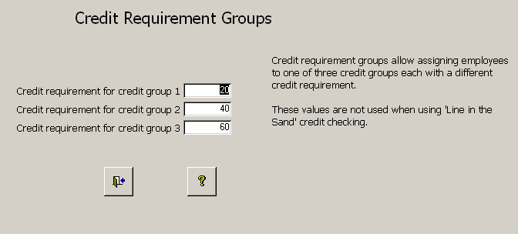
Fig. 2a

Configuration and Customization – a little review.
Before we get too far along it is important avoid any confusion with some of the new terms used in the program. It is important to know the difference between compliance groups and credit requirement groups. One sets a date and the other sets a value. Compliance groups are used to assign a compliance date for completing your credits. CLE Tracker allows up to 5 different compliance groups. So, some employees can be assigned to compliance group 1 with a certain compliance date for completing all their credits. Other employees can be assigned to compliance group 2,3,4 or 5 each with a different compliance date. Credit requirement groups replace the single State credit requirement value and allow you to assign up to 3 different credit requirements. So now employees can be assigned to 1 of 3 different credit requirement groups. This is useful where new professionals have different credit requirements than more senior professionals. An employee can only belong to one compliance group and one credit requirement group.

Design TIP
Using compliance groups and credit requirement groups are powerful ways to separate out certain employees that have slightly different credit tracking requirements. Even if your state organization assigns everyone the same reporting date, you could still use compliance groups all with the same date. The same thing for the credit requirement group, you could set all three credit requirement groups to the same value and assign employees to the different groups.

(9) Use ‘Line in the Sand’ credit limits. The ‘Line in the Sand’ credit limits feature is new to CLE Tracker version 4.0 and will be explained after we describe all the other features on the Configuration and Customization form.

(11) Use full date for passing exam. Use this checkbox to allow entering the full date that the employee passed their state exam. Otherwise, the program only stores the year the employee passed the exam.

(12) Enable tracking of seminar fees and other costs. Enable or disable displaying the seminar and other costs fields on forms and reports.

(13) Disable calculating the total credits column. This group uses inclusive credit accounting where the total credits are in column 1 but the credit columns are not added together.

Credit Types to Track. This is the second most important setting for configuring your database. This button displays a form for selecting the types of credits you need to track. (see Fig.3). Each state has different requirements for the types of credits and the number of credits that must be earned. CLE Tracker can track up to seven types of credits. You can edit these labels and descriptions or add new ones as needed. The Credit Types to Track is used for tracking those credits that are required credits for the employee to be in compliance.
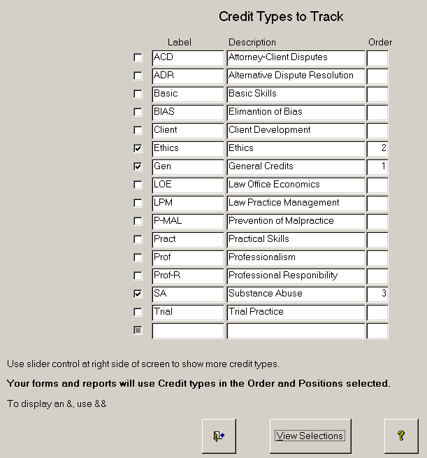
Fig. 3

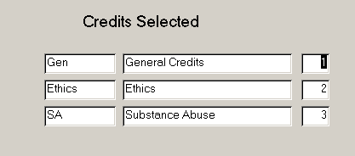
Fig. 4

Referring to Fig. 3, you select credit types using check boxes. When a credit type is selected, a number is assigned in the Order column to show the order this item was selected and in what position it will be displayed on screen forms and reports. Selecting a checkbox again will deselect the item. After making your selections, use the View Selections button to view the items you selected. (see Fig. 4) CLE Tracker has different types of credits to choose from and you can add more as needed. You can also edit these entries as desired. Use the exit button to return to the Configuration and Customization form.

Important Notice. Once you have started using CLE Tracker and have entered credit information, it is very important not to change these selections. CLE Tracker will always use seven internal columns for holding credit information. The Credits selection form (fig 3) allows you to select which of these seven columns to display and what headings to use on forms and reports. For example, if you selected A&A (Accounting and Auditing) as your third selection and then entered credit information in this field, CLE Tracker will display the third column using the A&A labels. If you now go back to this form and change your selections so that A&A is now in the second position and Tax is in the third position, CLE Tracker will display the new labels as you selected but it will not move any of the information already entered in these columns. Likewise, if you deselect a column after already entering information, CLE Tracker will no longer display this field (column), but will continue to use the existing data already entered in computing credit totals.

Figures 5 and 5a show the effect of your selections on a credit report and the Credits Information form.
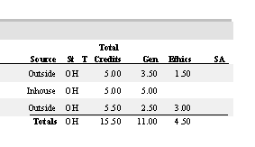
Fig. 5
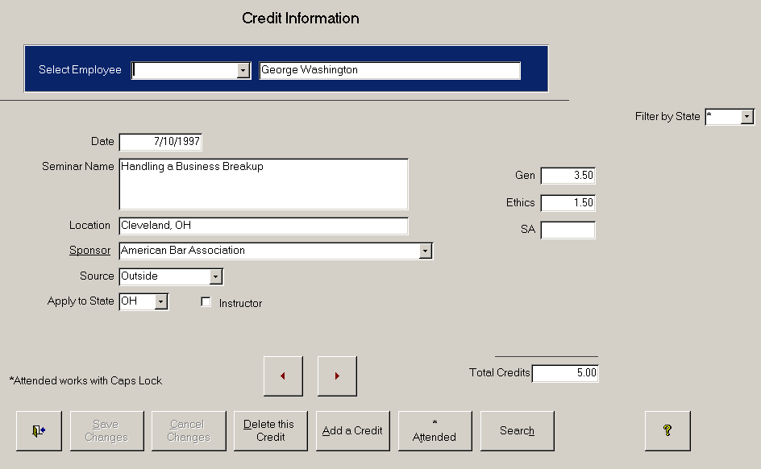Fig. 5a

More about Credit Types to Track.
As was mentioned before, the Credit Types to Track is the second most important setting for configuring your database. If you plan to use the ‘Line in the Sand’ credit checking feature, then selecting the Credit Types to Track is even more important. The Credit Types to Track is best used for tracking those credits that are required credits for the employee to be in compliance.

In addition to tracking required credits many firms like to track other items such as teaching credits. Notice in Fig 5a above there is an “Instructor” checkbox for declaring that these credits were earned as an Instructor or Teacher. So in the case where an employee is both an Instructor and an attendee at the same event, the employee could have this same credit event entered twice, once showing the credits earned as an attendee and again to show the number of teaching credits. There are methods to report just these teaching credits. If Teaching credits are a required Credit type than you could select Teaching Credits as a Credit Type to Track in Fig 3. Another option is to use “Credit Sources” to track teaching credits. Credit Sources are described below.
Design TIP.
If you know that this same database will be used to track credits for more than one state organization, then you will need to select the Credit Types to Track needed for each organization. For example, one state may only require meeting two credit requirements and another state may require three credit requirements. So, you could select these 5 different credit types.

Credit Sources Use the credit sources button to select the different sources of credits to track. Selecting the button opens the form shown below. You can track up to 7 different sources. It is very important that you not change a credit source once you have started to use it. Credit sources do not create a Credit column to allow credit checking, but using credit sources allows creating subtotals of credits earned by these different sources. Also, there are Crosstab reports that show the amount of credits earned through these different credit sources.

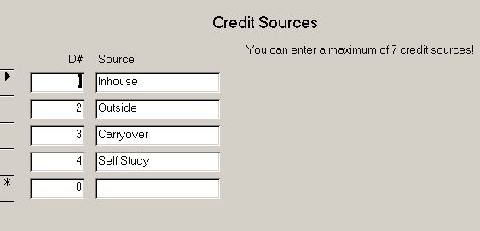

Offices. Optional - Enter the office locations of employees whose credits you are tracking. There are many reports that allow you to report only information for a particular office.

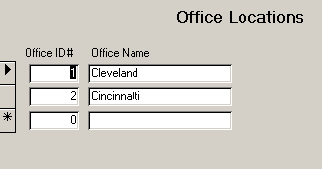

Practice Groups. Optional - Enter the practice areas that employees in your firm are grouped.
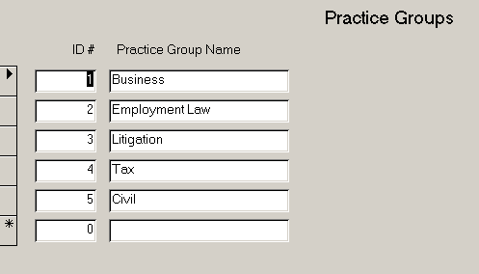

Employee Status. Use the Employee status table to indicate the employee as a CPA, Auditor, Inspector, Agent or whatever your needs.

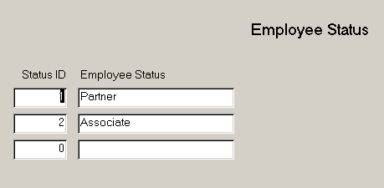

Use ‘Line in the Sand’ credit limits. Selecting the checkbox will display a button to access the ‘Line in the Sand’ form in Fig 6.

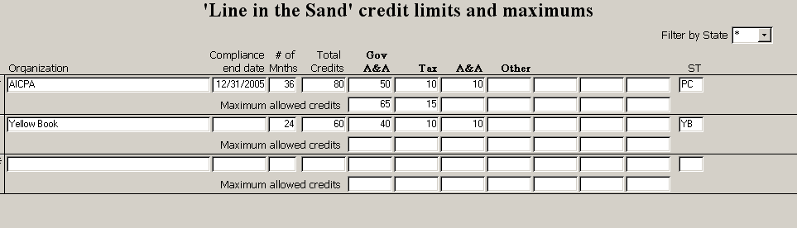

Fig 6

The ‘Line in the Sand’ feature overrides many of these previous settings and greatly expands the capabilities of CLE Tracker. It provides four main features: multiple credit requirements, individual column credit requirements, multiple date ranges and credit checking.

Multiple credit requirements: Each state organization can have their own credit requirements. Referring to Fig 6, we see 80 credits are required for PC and 60 credits required for YB. Also, each credit column can have their own credit requirement AND their own credit maximum.

Multiple date ranges: Each state organization that you track credits for can have their own compliance end date and # of months. In the example above, the program will only report those credits for state PC for the 36 months ending 12/31/2005 AND the credits for state YB for the 24 months. (the end date will be selected from previous configuration settings)

The ‘Line in the Sand’ feature can be combined with compliance groups and credit requirement groups. When these additional features are enabled, additional fields will appear to make the selections. (see below) Using both of these other features you could now have up to 15 different credit requirements or 15 different date ranges for the each state organization.

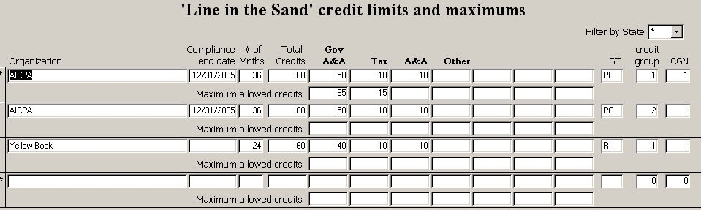

Credit checking: Credit checking occurs at the end of the credit report. The credit checking feature is best explained by example. Referring to Fig 6 (above), we see 80 total credits are required for PC. And 50 credits are required in Gov A&A (col 1) and 10 credits are required in Tax (col 2) and 10 credits are required in A&A (col 3). And there is also a credits maximum line of 65 max credits in Gov A&A (col 1) and 15 max credits in Tax (col 2).

So, after CLE Tracker displays the Totals line, it then shows the credits maximum line and computes the adjusted totals line (including a new total credits amount). Next it displays the credit requirement line and subtracts each column. Any negative values show that the employee did not have enough credits to cross the ‘Line in the Sand’.

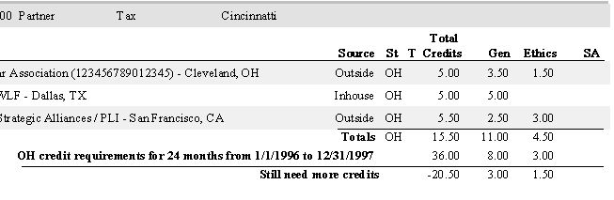
Fig 6a

This employee did not ‘Cross’ the Line in the Sand and still needs to earn additional credits.
Notice the requirements line from the ‘Line in the Sand’ table.
OH credit requirements for 24 months from 1/1/1996 to 12/31/1997. This is the date range used to select only those credits earned within this date range.

The text on the last line of the credit report comes from the PASS/FAIL table and can be modified.

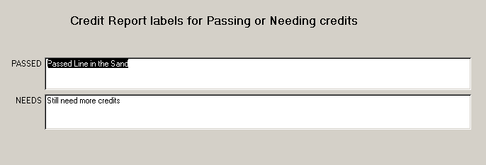
Program Settings. The program settings button will open the program settings form shown below. (Fig 7). The program settings affect program features for the CLE Tracker installed on your computer. It will not affect other users that may be connected to the same database.
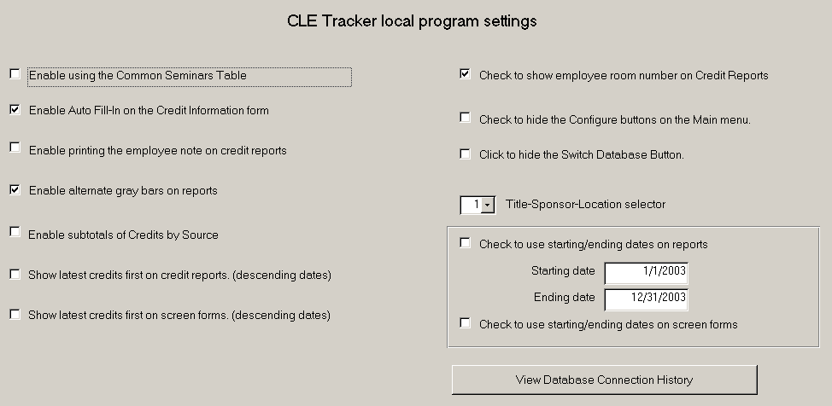Fig 7.

Enable using the Common Seminars Table
Enable using a common seminars table so that the same seminar information is available when you switch to a different back-end database.

Enable the Auto-fill feature
Enable or disable the auto-fill feature on the Credit Information form.

Enable printing the employee note on the credit reports
Use this command to print the employee note at the end of the CLE credit report.

Enable subtotal of CLE Credits by Source
Enable or disable grouping and sub-totaling of credits by their source.

Show latest credits first on credit reports. (descending dates)
Change the sort order for listing credits to show the latest credits first on credit reports.

Show latest credits first on screen forms. (descending dates)
Change the sort order for listing credits to show the latest credits first on screen forms.
Check to use Employee Mailing Address. Check this box to display the employee mailing address on CLE Credit reports.

Check to hide Configuration and Settings buttons. Check this box to hide the configuration and program settings buttons on the main menu. The configuration and program settings buttons should be hidden to prevent the casual CLE Tracker user from gaining access to these settings. When these buttons are hidden you may still gain access to the customization and configuration form by double clicking on the word "Continuing" at the lower left corner of the Main Menu or by using the Alt C keyboard shortcut.

Click to hide the Switch Database button
Enable or disable the Switch database button.

Title – Sponsor - Location
The Title – Sponsor – Location selector is used to control the amount and order of CLE seminar information in the credit reports. There are 3 options.

0 | Seminar title
1 | Seminar title, Sponsor, location
2 | Sponsor, location, Seminar title

Check to use starting/ending dates on reports.
Checking this box will limit the reporting of CLE credit information to the starting and ending dates entered below. When checked, the main menu will display the report date range as shown in Fig 1.

Reports starting date and Reports ending date.
The Report starting and ending date fields are used to limit reporting of only those CLE credit entries that are within this date range. All reports created with the date range enabled will contain a note in the report footer that this report spans these dates.

Check to use starting/ending dates on screen forms.
Checking this box will limit the on-screen display of CLE credit information to the starting and ending dates entered below. When checked, the main menu will display the report date range as shown in Fig 1.

View database connection history.
Selecting this button will display a listing of all the backend databases that have been connected to this program. It will display the database name and the file path.

CLE Tracker front to back
CLE Tracker consists of a front-end program (.mde) and at least one back-end database (.mdb). The front-end program portion of CLE Tracker contains all of the user menus, screen forms, queries and reports and should be installed locally on each PC where you want to run CLE Tracker. (C:\CLE is the recommended location). The back-end database file contains all of your CLE information tables and customization settings, employee information and credit entries. This file can be re-named as needed. The front-end portion of CLE Tracker connects to the different back-end databases locally or over a local area network.

Network setup - running CLE Tracker on a local area network
CLE Tracker is a multi-user application allowing multiple users to view and update CLE data at the same time. To allow multiple users, install the CLE Tracker program on each PC where you wish to run CLE Tracker. The back-end database portion of CLE Tracker
(i.e. CLE_Trkr_Data.mdb) will need to be installed on a shared network drive accessible to all users that wish to run CLE Tracker. See your network administrator on how to attach shared network drives to your computer. Move the back-end database portion of CLE Tracker (CLE_Trkr_Data.mdb) from one of the PCs to the shared network drive location. Delete the back-end database portion of CLE Tracker (CLE_Trkr_Data.mdb) from each PC where CLE Tracker is installed. Use Windows explorer or some other method to delete this file. Because of the nature of Access and how it retrieves data from the database it is not recommended to run CLE Tracker over a wide-area-network. Doing so will slow down your WAN links and depending upon the number of program licenses you purchased you could be violating the program license agreement.

A typical CLE Tracker installation is to have the CLE Tracker front-end installed at each required computer and the back-end database portion of CLE Tracker stored on a shared network drive on a file server. The file server is backed up to tape or other back-up media each night thus protecting your CLE back-end database. There is no need to backup the front-end portion of CLE Tracker.

Show CLE Tracker where to find the database file
When CLE Tracker starts it automatically connects to the database it was last connected to. If for some reason it cannot connect to this database, it will look for the database file in the C:\CLE directory on the PC where CLE Tracker is installed. If you moved the database file to a network drive or other location, CLE Tracker will display a message telling you that it cannot find the database file, along with the name of the file it was looking for. It will then display a file dialog box allowing you locate the database file (CLE_Trkr_Data.mdb or whatever name you have used) manually. Locate and select the database using the file dialog box and select OK. CLE Tracker will connect to the database and resume starting the program. The next time CLE Tracker starts it will remember the name and location of the database file and automatically connect to it provided the network drive is still attached to your computer.
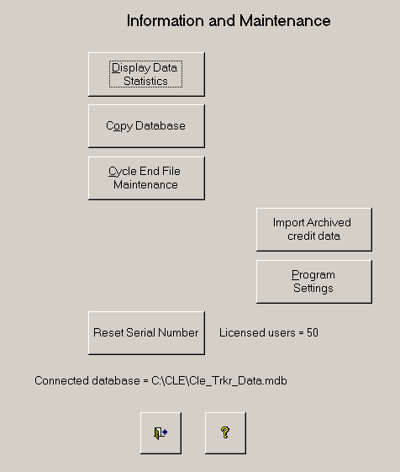

Fig 8

Peer to Peer Networks - Do Not Share your \CLE directory
If you wish to share the CLE database files stored on one of the computers that will also be used to run CLE Tracker you still need to move the database file to a different file location other than C:\CLE. Do not share your C:\CLE directory to other computers. This situation occurs when you do not have a file server and wish to share your data using a peer to peer network.

Create a new directory on the computer that will be sharing out the CLE Tracker database files and share this new directory. Consult your computer operating system manual or help system on how to create a directory and share it. Move the CLE Tracker database file (CLE_Trkr_Data.mdb) from the C:\CLE directory to this shared directory you created. Make sure the data file is moved and not just copied because CLE Tracker will automatically look in the C:\CLE directory and connect to the data file if it is found there.

The reason you should not share your C:\CLE directory is that CLE Tracker uses this location to store a file lock when opening the tables. The file lock is what allows other users to use CLE Tracker at the same time and prevents two users from making changes to the same information. If another copy of CLE Tracker running on a different computer was attached to your C:\CLE directory it would see this file lock and try to use it also, resulting in a sharing violation error. The sharing violation occurs on the file lock and not the database file.

Multiple Back-End Databases
One of the great features of CLE Tracker is the ability to connect to different back-end databases. This allows creating different back-end databases for the different states where you wish to track credit and seminar information. Users select a different back-end database by double clicking the State code in the lower left-hand corner of the main menu screen of with the keyboard shortcut, Alt-S. See fig 9.

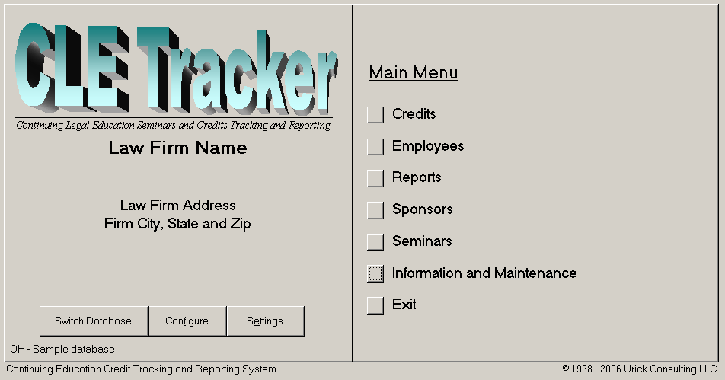
Fig. 9

Double clicking the State code will display a file menu allowing the user to connect to a different back-end database. Connecting to different back-end databases will not affect other users that may be connected to other back-end databases. Each database allows multiple users and users can connect to the different databases as needed. When you select to connect to a different back-end database, CLE Tracker will disconnect the current database and then connect to the new database. Databases stored on network file servers can take several minutes to complete the connection process depending upon network speed and the size of the database.

Although CLE Tracker was written to allow multiple users to run at the same time, it is recommended to keep the number of users to a minimum and to stress to users that they should use CLE Tracker for their needs and then exit from the program as soon as possible. Problems could occur when a computer running CLE Tracker crashes for any reason, it can leave the database in an open condition, which could lead to file corruption. Keeping the number of users to a minimum reduces the chances of this occurring and also helps reduce network traffic.

Making multiple back-end databases
The best approach to creating multiple back-end databases is to start with one back-end database on a file server and configure it with your firm’s information, state credit requirements and employee information. Then use CLE Tracker to make additional copies of this database. Use the “Copy Database” button from the Information and Maintenance form shown below. CLE Tracker will prompt you for a database name and create a copy of the current database in the same directory. Use descriptive names to assist other users when they need to locate and connect to this back-end database. Avoid using blanks in the name and use the underscore character instead. CLE Tracker automatically adds the MDB file extension to the name you enter. For example, you could have a back-end database called OHIO2001.MDB and another called CA2000.MDB. CLE Tracker can then switch between these two databases as needed.

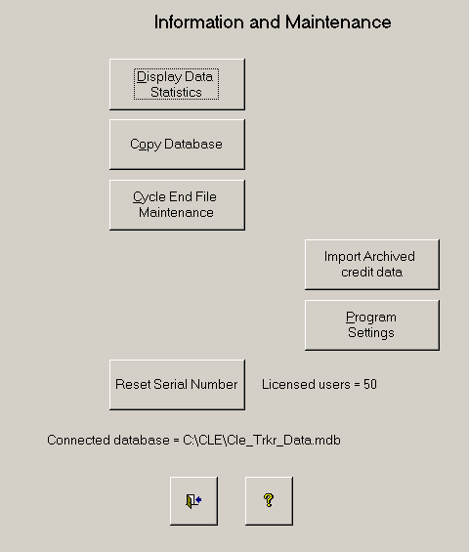
Fig 10.

Opening the back-end database file
The back-end database portion of CLE Tracker may be opened directly using Microsoft® Access. A password is required to open the file. The password is "pda3034". When opening the database directly using Microsoft ® Access the following form will appear to notify you that you are requesting to gain access to the raw CLE Tracker information. See figure 11. If you wish to open the data file, select the button, 'Open Anyway'.
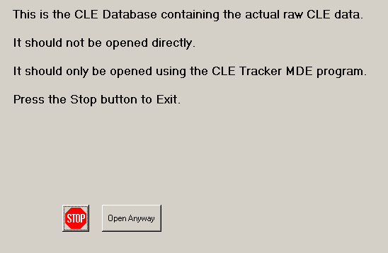

Fig 11

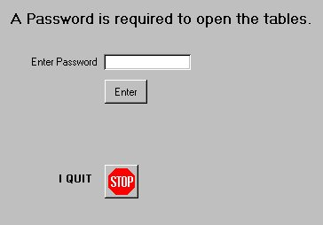
Selecting the button 'Open Anyway', will display the form shown below in figure 12.
Fig 12

To open the data tables enter the password.

